Sutton Academy uses MFD Framework and makes potential saving of £24,000

Elton Head Rd,

Saint Helens

WA9 5AU

01744 678859

contact@thesuttonacademy.org.uk
The Background
The Sutton Academy (formerly known as Sutton High School) is a medium-sized Academy accommodating 1300 students from ages 11 to 18. The Academy is sponsored by St Helens College.

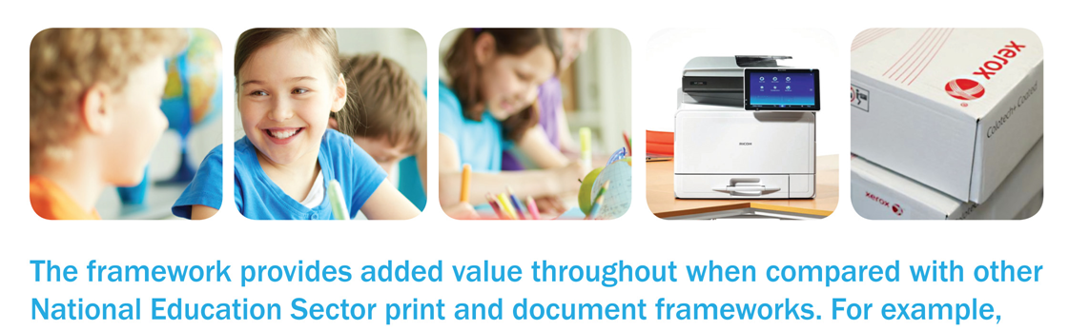

The Process
The Academy used the CPC Multifunctional Devices and Associated Print Services and Supplies framework. It was actually their first tender since they achieved Academy status in 2010.

The Academy raised a request for quote using the CPC Quote Tool which sends the quote request to all the suppliers who are on the relevant Framework Lot. A total of three suppliers responded to the quote request. Following evaluation of the bids, the contract was awarded to Ricoh.
Chief Finance Officer Jayne Tallant said: “The supplier has delivered on all promises and provided useful advice in a friendly and professional manner.”
Commenting on the CPC Quote Tool Jayne said: “The Quote Tool is user friendly and I used it because it had been used by the Academy’s sponsor, St Helens College. It was a quick and easy way of ensuring compliance with purchasing procedures.” Jayne also said: “I phoned through to the Helpdesk on a couple of occasions too and received really helpful advice which was invaluable as a new user.”
Account Manager, Ben Bramhall said: “Ricoh did not take the tender document at face value, but visited the customer to properly understand their requirements before responding. At presentation stage, we not only presented our solution but brought out some issues that the customer may not have considered (such as space planning) to ensure they made an informed choice and that there would be no hitches during installation. Special care was taken over the specification of the fleet devices and that it would work in a school corridor environment.”

The Outcome
By utilising the CPC framework, the Academy has made an estimated potential saving of £24,000. Jayne Tallant has said the Academy would use the framework again and was happy with the level of support she received throughout her experience.
It was the first time the Academy had used the CPC Quote Tool and from a CPC perspective, it’s great to know they achieved such a successful outcome.

